**Week 6-4.React JS-HOL**

**Name-Adi Jain**

**Superset ID- 6390400**

**Hands on**

Create a new react application using *create-react-app* tool with the name as “blogapp”.

**Code**

**File Name: post.js**

import React from 'react';

class Post {

  constructor(id, title, body) {

    this.id = id;

    this.title = title;

    this.body = body;

  }

}

export default Post;

**================================================================**

**File Name: posts.js**

import React, { Component } from 'react';

import Post from './post';

class Posts extends Component {

  constructor(props) {

    super(props);

    this.state = {

      posts: []

    };

  }

  loadPosts = () => {

    fetch('https://jsonplaceholder.typicode.com/posts')

      .then(res => res.json())

      .then(data => {

        const posts = data.map(post => {

          return new Post(post.userId, post.id, post.title, post.body);

        });

        this.setState({ posts });

      })

      .catch(err => {

        alert("Error fetching posts: " + err.message);

      });

  };

  componentDidMount() {

    this.loadPosts();

  }

  componentDidCatch(error, info) {

    alert("An error occurred: " + error.toString());

  }

  render() {

    return (

      <div>

        <h2>Posts</h2>

        {this.state.posts.map(post => (

          <div key={post.id}>

            <h3>{post.title}</h3>

            <p>{post.body}</p>

          </div>

        ))}

      </div>

    );

  }

}

export default Posts;

**========================================================**

**File Name: app.js**

// src/App.js

import React from 'react';

import Posts from './posts';

function App() {

  return (

    <div className="App">

      <Posts />

    </div>

  );

}

export default App;

**========================================================**

**Output**

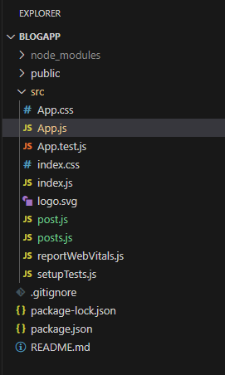

**Folder Structure**



